**BUSINESS ANALYTICS**

Table of Contents

1.0 Introduction 3

2.0 Critical Evaluation of Survey 3

3.0 Analytical Solution 4

3.1 Analytical Solution 1 [SAP Lumira] 5

3.1.1 Market Opportunities 5

3.1.2 Targeted Customers 5

3.1.3 Channel for campaigns 6

3.1.4 Overall Strategies 6

3.2 Analytical Solution 2 [PowerPivot] 7

3.2.1 Market Opportunities 7

3.2.2 Targeted Customers 7

3.2.3 Channel for campaigns 8

3.2.4 Overall Strategies 8

4.0 Recommendations and Conclusion 9

References 10

# 1.0 Introduction

The health, beauty and wellness industry all over the globe has evidenced all time high demand. In order to address such high demand, the pharmaceutical, personal care, and nutritional industries have converged and formed a new industry (Ragsdale, 2014). However, it has seen that based on the products marketed in this specific industry, it can be further sub-divided as following three segments:

a. Cosmeceuticals

b. Nutricosmetics

c. Nutraceuticals

According to the given information, there is a 4-8% annual global growth across all three market segments. However, one notable aspect is there that major market share in Nutricosmetic markets are covered by China and Japan and USA dominates Nutraceutical. Nevertheless, the cosmeceutical market is still in the developing stage.

Beauty and Personal care in Australia enrolled a solid execution in 2016, with current esteem development being to a great extent in accordance with the earlier year's solid development. Customers in Australia are enormous spenders on beauty and personal care, especially within color beauty care products and healthy skin (Shmueli and Lichtendahl Jr, 2017). Millennial shoppers have turned into a key target aggregate for magnificence and individual care organizations, as they have a tendency to take after patterns in the business intently and make visit buys in light of new item asserts, application techniques and equations. The performance of beauty and personal care product though increasing year on year, there is no specific stats and thus it is noteworthy to analyze the emergence of these industry segments in Australia (Sharma et al. 2014). As an end-user survey has been already conducted and the data available for analysis, the analyst has developed two different set of analytical solutions with the help of SAP Lumira and PowerPivot. Subsequently, the analyst has reported a list of recommendations related to market opportunities, targeted customers, channels for campaigns, etc.

# 2.0 Critical Evaluation of Survey

As reported in the provided contextual study, end user survey has been as of now directed and the information is accessible for analysis. This segment of the study is aimed at exploring the appropriateness of this survey (Laursen and Thorlund, 2016). Since, the point was to recognize the opportunity for acquiring market share in this newly formed industry; it was clear decision to gather data from those respondents, who have the enthusiasm for these items. At the end of the day, this overview must be needed to think of one as such inquiry, which can arrange respondents into two classes; one who know something about these items and prepared to buy and one who have no such thought (Holsapple et al. 2014). It has seen that the review began with the inquiry, "Are you a normal buyer of beauty, wellbeing and health items?" and the information was gathered from consistent purchasers of magnificence, wellbeing and health items. Subsequently, one might say that the overview poll intended for this review set legitimate tone for this market. An overview is named as a powerful one gave it underpins the investigator to investigate both statistic profile and in addition mindfulness about the subject of study. Starting here of view as well, it can be contended that this study poll has considered a rundown of statistic variable began from state to wage, age band and gender (Acito and Khatri, 2014). These factors are basic for distinguishing market openings, directed clients and partner techniques (Dubey and Gunasekaran, 2015). Once more, this study survey has likewise included inquiries that are required to comprehend the new item dispatch procedures. Thus, it can be inferred that the information gathered utilizing this overview poll most likely give bits of knowledge about the Australian excellence, social insurance and prosperity showcase (Lim et al. 2013).

The review question general appeared to be great to gather essential data for Australian excellence, medicinal services and prosperity advertise, notwithstanding, questions identified with limited time techniques, in the case of giving offer and rebate will impact the buy choice or not are important to depict the market appropriately. These inquiries are lost here.

# 3.0 Analytical Solution

In this segment of the report, the two-diverse model of analytical solutions outlined with the assistance of SAP Lumira and Microsoft Excel [PowerPivot] systematic instrument are used. While condescending the models, the specialist endeavored to show the conceivable market fragments, target clients, promoting channel fundamental and effortlessness of spreading data about the item lastly item frame. The investigative model planned with the assistance of SAP Lumira picture the information gathered through this study survey (Vera-Baquero et al. 2013). Then again, the pivot charts planned with the assistance of exceed expectations shows numerical figures.

## 3.1 Analytical Solution 1 [SAP Lumira]

### 3.1.1 Market Opportunities

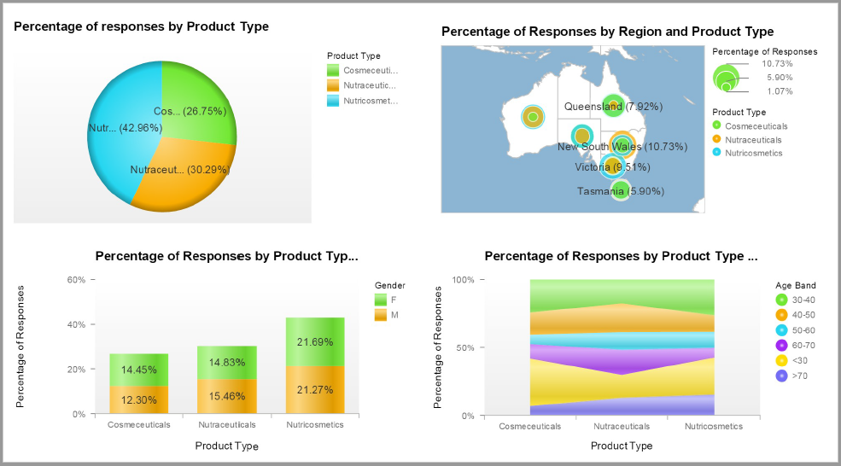

### 3.1.2 Targeted Customers

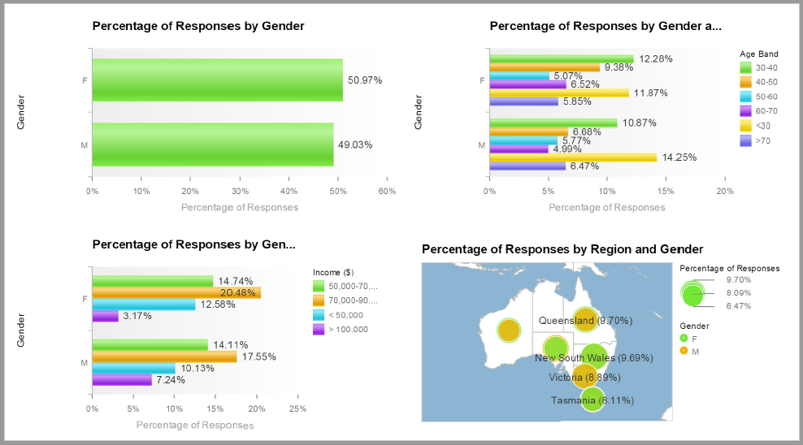

### 3.1.3 Channel for campaigns

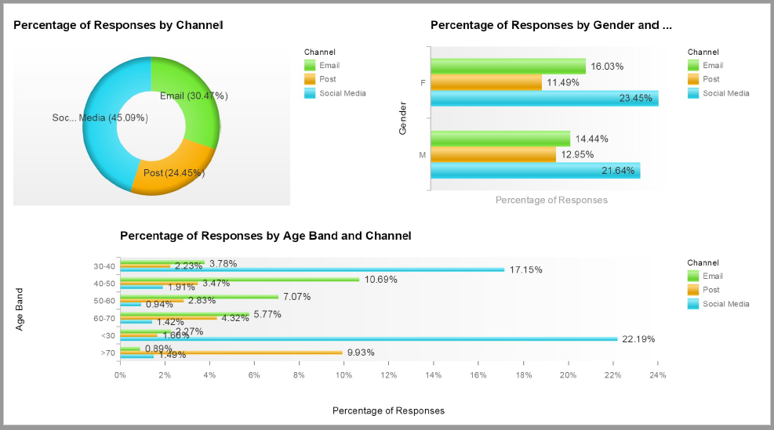

### 3.1.4 Overall Strategies

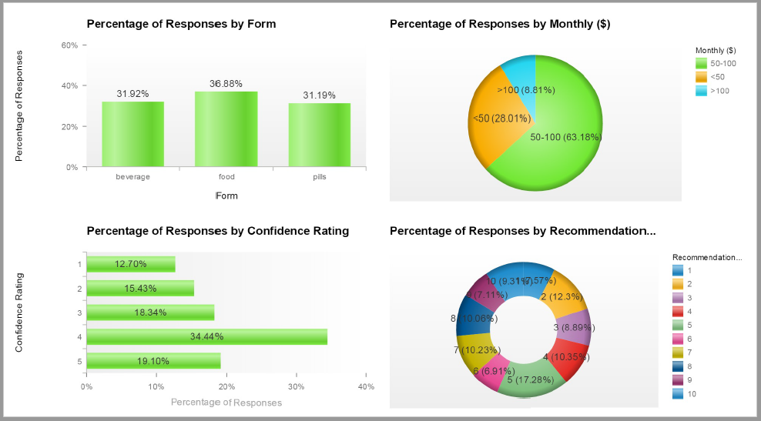

## 3.2 Analytical Solution 2 [PowerPivot]

### 3.2.1 Market Opportunities

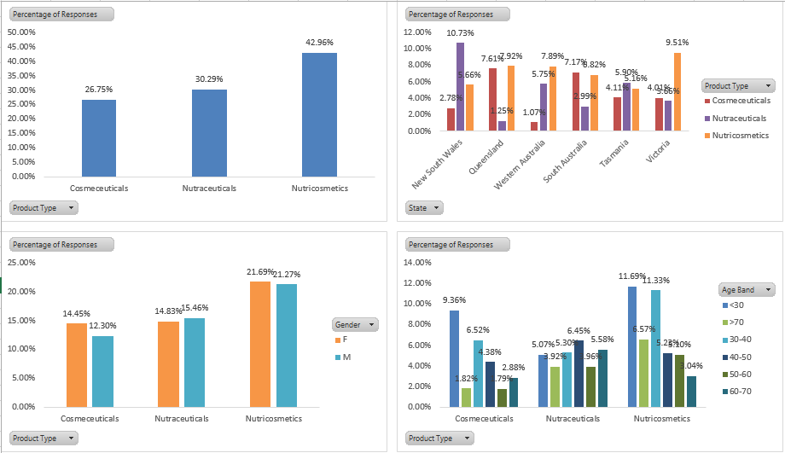

### 3.2.2 Targeted Customers

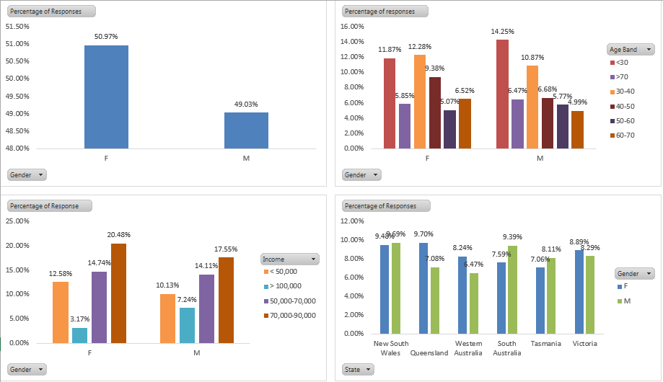

### 3.2.3 Channel for campaigns

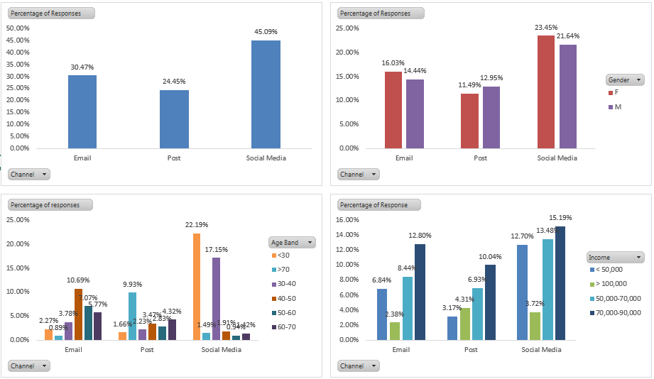

### 3.2.4 Overall Strategies

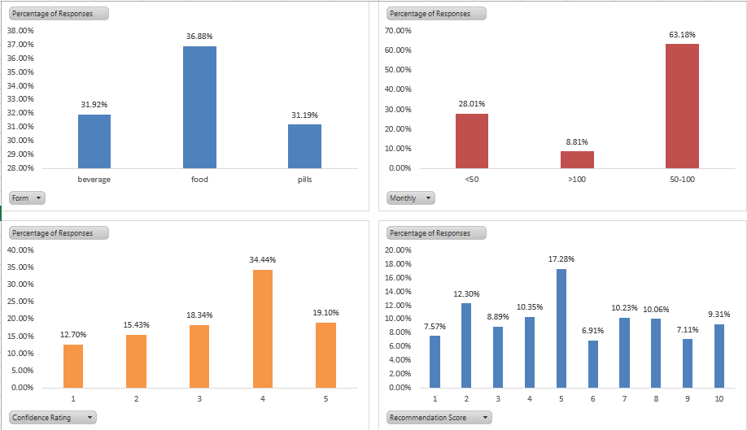

# 4.0 Recommendations and Conclusion

This area of the report is critical as the examiner has clarified the outcomes found from both analytical models. Further, a rundown of proposals has been given by the analyst. The principal point of building up these two models was to distinguish which showcase section is in the need rundown of Australian client (Wixom et al. 2013). Allude to figure 1 from model 1 and in addition figure 1 from model 2, one might say that Nutricosmetics item is sought after in the Australian market. As indicated by figure 1 in model 2, there is very nearly 41% respondent’s demonstrated enthusiasm about this sort of items. The diagnostic model 1 (figure 1) additionally researched the market portions concerning sexual orientation and age. While 20% male demonstrated enthusiasm for this item, right around 22% ladies likewise quick to utilize this item. Once more, from this figure, one might say that individuals with age up to 40 years are significantly demonstrating enthusiasm for this item (Duan and Xiong, 2015). Subsequently, it can be suggested that the objective market ought to be Nutricosmetics for ladies with greatest 40 years of age. Further, it can likewise be suggested that Victoria and Queensland would the primary need to dispatch such items.

While discussing target client, both the systematic models have indicated distinctive view point and on the premise of these figures and perceptions (figures 2, 3 and 4 from both models) one might say that female with wage level 70000 – 90000 ought to be focused on. If there should be an occurrence of promoting channel, it has seen that utilization of online networking will be the essential decision like other real industry. The expository model 1 has demonstrated that 30% of the objective clients are leaning toward online networking as a viable approach to contact them. They additionally jump at the chance to get refresh about the item through this showcasing channel as they for the most part invested their extra energy in utilizing online networking. Thus, it can be suggested that web-based social networking advertising ought to be the principal need for marking this item. In the meantime, messaging is another imperative route through which focused client need customary refresh about the new item. Henceforth, it is prescribed to keep up a client database and association’s works in this industry needs to send letters refresh to the majority of their current clients. The figure 4 condescended in display 2 has demonstrated that 43.85% of respondents specified that they will allude to their companion about this item. Thus, messaging would be next critical method for doing marking.

From the scientific model 1, it has seen that they will prepared to burn through 50-100 dollar in a month for this sort of item. Consequently, it is important to alter valuing of these item as indicated by their desire. At long last, it is seen that all most 16% of the respondents have said either as sustenance or pill frame would be the best for such item. Thus, it is prescribed to consider these two frames while presenting new items in the market.

# References

Acito, F. and Khatri, V., 2014. Business analytics: Why now and what next?.

Duan, L. and Xiong, Y., 2015. Big data analytics and business analytics. *Journal of Management Analytics*, *2*(1), pp.1-21.

Dubey, R. and Gunasekaran, A., 2015. Education and training for successful career in Big Data and Business Analytics. *Industrial and Commercial Training*, *47*(4), pp.174-181.

Holsapple, C., Lee-Post, A. and Pakath, R., 2014. A unified foundation for business analytics. *Decision Support Systems*, *64*, pp.130-141.

Laursen, G.H. and Thorlund, J., 2016. *Business analytics for managers: Taking business intelligence beyond reporting*. John Wiley & Sons.

Lim, E.P., Chen, H. and Chen, G., 2013. Business intelligence and analytics: Research directions. *ACM Transactions on Management Information Systems (TMIS)*, *3*(4), p.17.

Ragsdale, C., 2014. *Spreadsheet Modeling and Decision Analysis: A Practical Introduction to Business Analytics*. Nelson Education.

Sharma, R., Mithas, S. and Kankanhalli, A., 2014. Transforming decision-making processes: a research agenda for understanding the impact of business analytics on organisations. *European Journal of Information Systems*, *23*(4), pp.433-441.

Shmueli, G. and Lichtendahl Jr, K.C., 2017. *Data Mining for Business Analytics: Concepts, Techniques, and Applications in R*. John Wiley & Sons.

Vera-Baquero, A., Colomo-Palacios, R. and Molloy, O., 2013. Business process analytics using a big data approach. *IT Professional*, *15*(6), pp.29-35.

Wixom, B.H., Yen, B. and Relich, M., 2013. Maximizing Value from Business Analytics. *MIS Quarterly Executive*, *12*(2).